
AquaInsight
Data-Driven Strategies for Potable Water Assurance

Submitted for

DATA VISULIZATION AND DASHBOARD

Submitted by:
E23MCAG0131 Aakriti Jain
E23MCAG0014 Shreyanshi mukesh
E23MCAG0061 Nitesh kumar

Submitted to-
Dr. Nitin Arvind Shelke

SCHOOL OF COMPUTER SCIENCE AND ENGINEERING

MCA-1ST YEAR (DATA SCIENCE)

INDEX

Sr No
Content | Page No
1. | Abstract | 4
2. | INTRODUCTION AND RELATED WORK | 4-6
3 | SOFTWARE USED | 7
4. | METHODOLOGY | 8-9
5 | EXPERIMENTAL RESULTS | 9-11
6. | CONCLUSION | 12
7. | Implications and Future Work | 13
8. | References | 14

LIST OF FIGURES

Figure No. | Title | Page No.
1 | fig 1 | 8
2 | Fig2 | 8
3 | Fig 3 | 9
4 | Fig 4 | 10
5 | Fig 5 | 11

ABSTRACT
The "Water Quality and Potability" project addresses the critical issue of ensuring safe drinking water for communities. With a focus on evaluating water quality parameters, this project employs machine learning models to predict the potability of water based on a diverse set of chemical and physical attributes.

The dataset utilized in this study comprises features such as pH, hardness, solids, chloramines, sulfate, conductivity, organic carbon, trihalomethanes, and turbidity. The target variable, potability, distinguishes between potable (safe for consumption) and non-potable water.

The project's methodology involves thorough data preprocessing, encompassing the handling of missing values, outlier detection, and data standardization. Exploratory Data Analysis (EDA) techniques, including pair plots, histograms, and QQ-Plots, offer insights into the relationships between variables and the distribution of data.

Machine learning models, namely Random Forest, XG Boost, Support Vector Classifier (SVC), Logistic Regression, and Multi-layer Perceptron (MLP), are employed to predict water potability. The models undergo training and evaluation, with the MLP model demonstrating the highest accuracy among the selected models.

The results are visualized through a bar plot, highlighting the relative performance of each model. The MLP model, with its superior accuracy, stands out as a promising tool for predicting water potability.

INTRODUCTION AND RELATED WORK
In order to ensure public health and sustain life, access a pure drinking water is very essential. Measuring water quality is very essential since contaminated water can cause a variety of medical problem. The goal of this research is to use machine and deep learning approach to address the problem of estimating potability and evaluating the purity of water.
pH value: PH is an important parameter in evaluating the acid–base balance of water. It is also the indicator of acidic or alkaline condition of water status. WHO has recommended maximum permissible limit of pH from 6.5 to 8.5. The current investigation ranges were 6.52–6.83 which are in the range of WHO standards.
Hardness: Hardness is mainly caused by calcium and magnesium salts. These salts are dissolved from geologic deposits through which water travels. The length of time water is in contact with hardness producing material helps determine how much hardness there is in raw water. Hardness was originally defined as the capacity of water to precipitate soap caused by Calcium and Magnesium.
Solids (Total dissolved solids - TDS): Water has the ability to dissolve a wide range of inorganic and some organic minerals or salts such as potassium, calcium, sodium, bicarbonates, chlorides, magnesium, sulfates etc. These minerals produced un-wanted taste and diluted color in appearance of water. This is the important parameter for the use of water. The water with high TDS value indicates that water is highly mineralized. Desirable limit for TDS is 500 mg/l and maximum limit is 1000 mg/l which prescribed for drinking purpose.
Sulfate: Sulfates are naturally occurring substances that are found in minerals, soil, and rocks. They are present in ambient air, groundwater, plants, and food. The principal commercial use of sulfate is in the chemical industry.
Conductivity: Pure water is not a good conductor of electric current rather’ s a good insulator. Increase in ions concentration enhances the electrical conductivity of water. Generally, the amount of dissolved solids in water determines the electrical conductivity. Electrical conductivity (EC) actually measures the ionic process of a solution that enables it to transmit current. According to WHO standards, EC value should not exceeded 400 μS/cm.
Organic carbon: Total Organic Carbon (TOC) in source waters comes from decaying natural organic matter (NOM) as well as synthetic sources. TOC is a measure of the total amount of carbon in organic compounds in pure water. According to US EPA < 2 mg/L as TOC in treated / drinking water, and < 4 mg/Lit in source water which is use for treatment.
Trihalomethanes: THMs are chemicals which may be found in water treated with chlorine. The concentration of THMs in drinking water varies according to the level of organic material in the water, the amount of chlorine required to treat the water, and the temperature of the water that is being treated. THM levels up to 80 ppm is considered safe in drinking water.
Turbidity: The turbidity of water depends on the quantity of solid matter present in the suspended state. It is a measure of light emitting properties of water and the test is used to indicate the quality of waste discharge with respect to colloidal matter. The mean turbidity value obtained for Wondo Genet Campus (0.98 NTU) is lower than the WHO recommended value of 5.00 NTU.
Potability: Indicates if water is safe for human consumption where 1 means Potable and 0 means Not potable.

LITERATURE REVIEW
1)Nida Nasir ª, Afreen Kansal ^{b}, Omar Alshaltone ª, Feras Barneih ª, Mustafa Sameer ^{c}, Abdallah Shanableh ª, Ahmed Al-Shamma-The data has been split into 75 % for training and 25 % for testing. Fig. 4 illustrates the 4 × 4 confusion matrix for each classifier (refer to Table 2), with their color-coded values. All the performance metrics have been calculated using confusion matrices of each classifier, as mentioned in Table 11. According to the estimates, CATBoost and RF performed better than other classifiers, with a slight margin of ~1 %. Followed by MLP, XGBoost, decision tree, SVM, and logistic regression.
2)Xiyan Xu ¹, Ying Liu ¹, Shuming Liu, Junyu Li, Guancheng Guo, Kate Smith--Cross-connection simulation of reclaimed water into potable water at MR of 30%, 10%, 3% and 1% were carried out. Water quality was monitored during the experimental runs using conventional online detectors that measured residual chlorine, pH, turbidity, conductivity, temperature, ORP and COD. The corresponding results are shown in Fig. S2. In the case of 30% and 10% MR, water quality parameters obviously varied according to the cross-connection event. Turbidity, conductivity and COD increased.

3) Amir Hamzeh Haghiabi;Ali Heidar Nasrolahi;Abbas Parsaie
In this paper, the performance of artificial intelligence techniques including GMDH, SVM and ANN were evaluated to predict the water quality components of Tireh River (Iran). To this end most dataset related well-known components, such as pH, SO₄, Na, Ca, Cl, Mg, HCO₃ etc., were collected. Results indicated that the applied models have suitable performance for predicting water quality components, however, the best performance was related to the SVM.

4) Salisu Yusuf Muhammad, Mokhairi Makhtar, Azilawati Rozaimee, Azwa Abdul Aziz and Azrul Amri Jama --This paper has used the Kinta River data to find the best classification model in determining the quality class of the water. After the experiments, it shows that the Lazy model using KStar algorithm had the most outstanding accuracy of 86.67% which is the best algorithm that can be used to classify the water quality class of River Kinta, Perak Malaysia. Future research will focus on the selection of models from the collection of models to find the most robust classification model for water quality.

SOFTWARE USED
There are range of software tools were used by the Aqua Insight
Data-Driven Strategies for Potable Water Assurance project for data analysis,
Data visualization, and AI application. The main software elements are:

Python Programming Language
- Python served as the primary programming language for the entire project. Python is widely adopted in the field of data science and machine learning due to its rich ecosystem of libraries and packages.
- Notebooks Jupyter
- For developing projects and records, Jupyter Notebooks provide an interactive platform. A smooth workflow is made possible by their ability to combine code, visualizations of data, and written descriptions.
- Packages and Libraries
- The following packages and libraries for Python were heavily utilized in this project:
- NumPy: NumPy was used to manage arrays and perform numerical calculations, They offer features for data management.
- Pandas: The dataset which includes the parameters related to water quality was cleaned up and handle by using Pandas, a potent data manipulation library.
- Matplotlib and Seaborn: These two tools were used to visualize data, enabling the creation of a wide range of plots and charts for examining data distributions.
- Scikit-Learn: Scikit-Learn offered machine learning tools and techniques for training, assessing, and testing networks. Scikit-Learn was used to implement models such as Random Forest, XG Boost, Support Vector Classifier (SVC), Logistic Regression, and Multi-layer Perceptron (MLP).
- Other Tools
- GitHub: It is a version control platform, was used for collaborative development and version management of the project code.
- Markdown: Markdown language was used for creating well-formatted documentation and reports.

METHODOLOGY ---

Fig-1
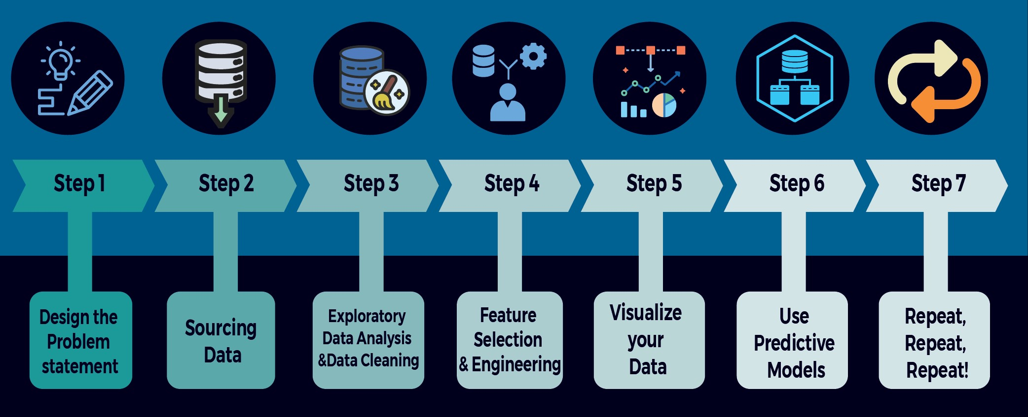
Fig-2

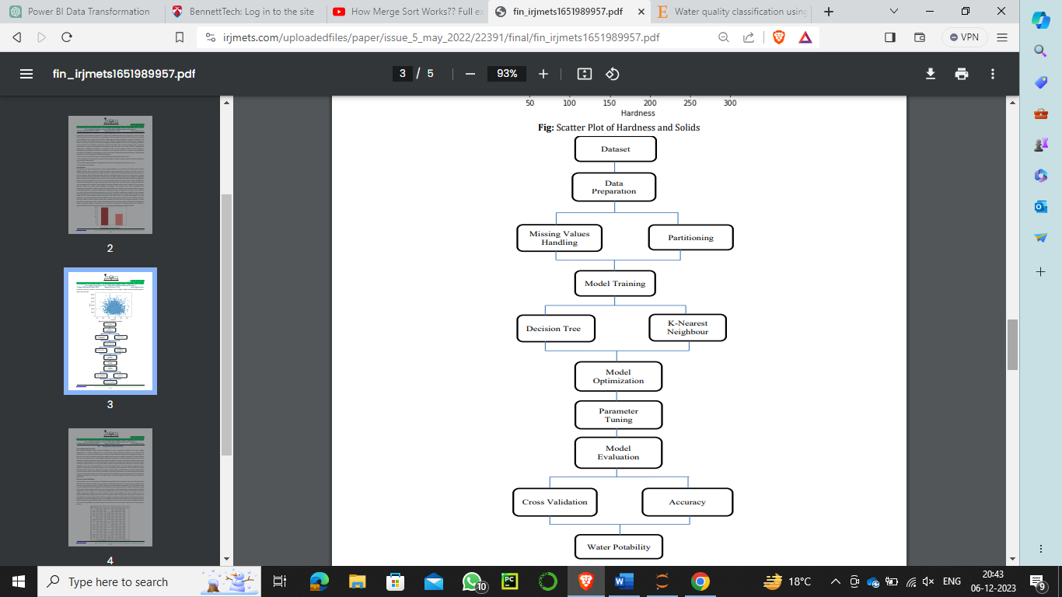

EXPERIMENTAL RESULTS
1. Data Preprocessing:
Imputation: Missing values in pH, sulfate, and trihalomethanes were filled using mean imputation.
Outlier Detection: Outliers were identified and removed using the Z-score method.
Standardization: Data was standardized to ensure consistent scaling.
2. Exploratory Data Analysis (EDA):
Visualizations: Pair plots, histograms, and QQ-Plots provided insights into data distributions and relationships between water quality parameters.
Fig-3
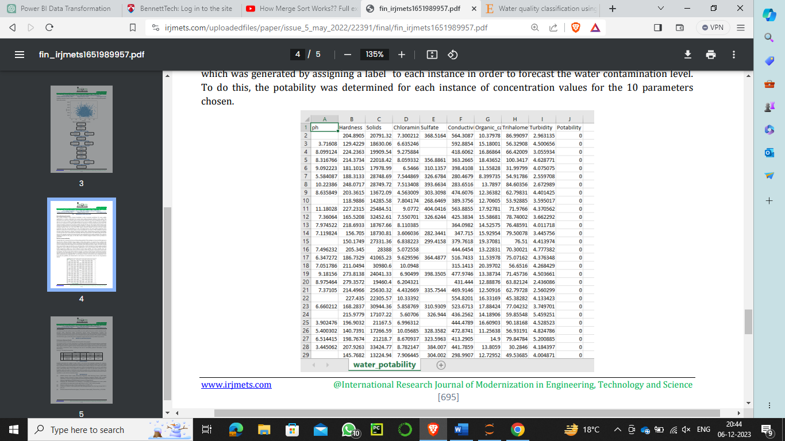

3. Machine Learning Models:
Implemented Models: Random Forest, XGBoost, Support Vector Classifier (SVC), Logistic Regression, and Multi-layer Perceptron (MLP) were employed.
Model Training: Models were trained on the preprocessed data.
4. Model Evaluation:
5. Visualization:
Bar Plot: A bar plot was created to visually compare the accuracy scores of each model. The MLP model demonstrated the highest accuracy.
POWER BI Dashboard:
fig-5
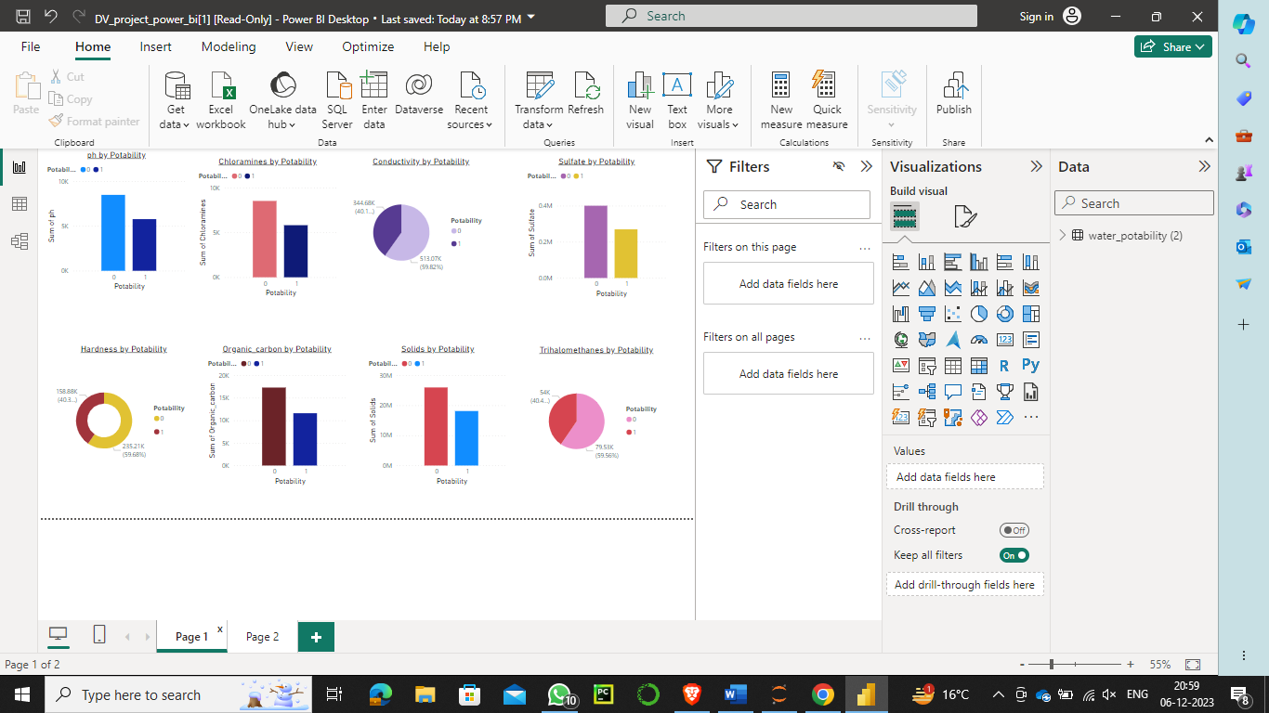
6. Conclusion and Implications:
Key Findings: Data preprocessing and exploratory analysis provided insights into water quality parameters. The MLP model outperformed other models in predicting water potability.
Implications: Accurate prediction of water potability has significant implications for public health.
7. Future Work:
Feature Importance: Further analysis could involve exploring feature importance to understand parameter contributions.
Hyperparameter Tuning: Fine-tuning hyperparameters might enhance model performance.
Collaboration: Collaboration with domain experts could improve model interpretability.
Fig-5

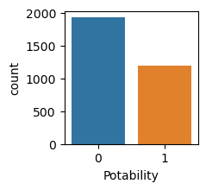
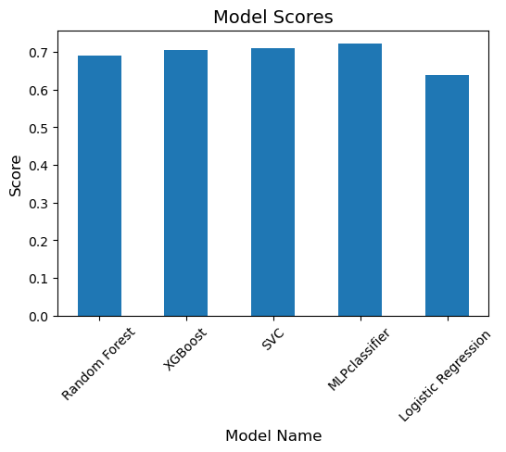

CONCLUSION
In the Water Quality and Potability project, we embarked on a comprehensive exploration of water quality parameters with the aim of predicting water potability. Leveraging machine learning models and a diverse set of data science tools, the project provided valuable insights into the safety of drinking water.
Key Findings:
Data Preprocessing:
Missing values in critical features like pH, sulfate, and trihalomethanes were handled using mean imputation.
Outliers were identified and removed through the Z-score method.
Data standardization was applied to ensure uniform scaling of features.

Exploratory Data Analysis (EDA):
Visualizations, including pair plots and histograms, provided a holistic understanding of the relationships between water quality parameters.
QQ-Plots were employed to verify the normal distribution of the data.

Machine Learning Models:
Random Forest, XG Boost, Support Vector Classifier (SVC), Logistic Regression, and Multi-layer Perceptron (MLP) models were implemented and trained.
The MLP model demonstrated the highest accuracy in predicting water potability.

Results and Visualization:
The performance of each model was visualized through a bar plot, showcasing the relative accuracy of predictions.
The MLP model outperformed other models, making it a promising tool for predicting water potability.

Implications and Future Work

Public Health Impact:
Accurate prediction of water potability is crucial for safeguarding public health, and machine learning models can serve as valuable tools for water quality assessment.

Further Analysis:
Future work could involve in-depth feature importance analysis to understand the contributions of each parameter to potability predictions.

Hyperparameter Tuning:
Fine-tuning of hyperparameters could potentially enhance model performance, ensuring more robust and accurate predictions.

Collaboration with Domain Experts:
Collaboration with domain experts in water quality and public health can provide additional insights, improving the interpretability of the models.

Final Thoughts
Making use of data science and machine learning to guarantee safe drinking water is made possible in large part by the Water Quality and Potability project. Communities and public health initiatives will ultimately benefit from the experiment's findings since they will be helpful in the future in building trustworthy tools for assessing and predicting water quality.
In summary, the initiative encourages more research and collaboration in the field where data science, environmental science, and public health intersect, and it shows how machine learning can be applied to real-world situations.

REFERENCES
1)https://www.researchgate.net/profile/Salisu-Muhammad-2/publication/281619411_Classification_Model_for_Water_Quality_using_Machine_Learning_Techniques/links/64102ed966f8522c38a30012/Classification-Model-for-Water-Quality-using-Machine-Learning-Techniques.pdf
2) https://www.sciencedirect.com/science/article/abs/pii/S2214714422003646
3) https://www.sciencedirect.com/science/article/abs/pii/S0301479719302701
4)https://iwaponline.com/wqrj/article/53/1/3/38171/Water-quality-prediction-using-machine-learning
5)https://www.irjmets.com/uploadedfiles/paper/issue_5_may_2022/22391/final/fin_irjmets1651989957.pdf

